## Environmental Science

## Digital

## Asignment-2

Name: Om Ashish Mishra

Registration Number: 16BCE0789

Slot: G2

Batch: 10(B.Tech Computer Science (Core))

# Topics ____________________________________________________

1. Kyoto Protocol…………………………………………………………………

2. Carbon sequestration methods…………………………………………………..

3. Montreal Protocol……………………………………………………………….

4. Bibliography……………………………………………………………………..

**KYOTO PROTOCOL** 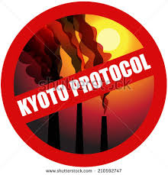

The **Kyoto Protocol** is an international treaty which extends the *1992 United Nations Framework Convention on Climate Change (UNFCCC)* that commits State Parties to reduce greenhouse gas emissions, based on the premise that (a) global warming exists and (b) human-made CO2 emissions have caused it. The Kyoto Protocol was adopted in *Kyoto, Japan*, on 11 December 1997 and entered into force on 16 February 2005. There are currently 192 parties to the Protocol.

The Kyoto Protocol implemented the objective of the UNFCCC to fight global warming by reducing greenhouse gas concentrations in the atmosphere to "a level that would prevent dangerous anthropogenic interference with the climate system" as per Article 2. The Protocol is based on the principle of common but differentiated responsibilities: it puts the obligation to reduce current emissions on developed countries on the basis that they are historically responsible for the current levels of greenhouse gases in the atmosphere.

The Protocol’s first commitment period started in 2008 and ended in 2012. A second commitment period was agreed on in 2012, known as the Doha Amendment to the protocol, in which 37 countries have binding targets: *Australia, the European Union (and its 28 member states), Belarus, Iceland, Kazakhstan, Liechtenstein, Norway, Switzerland, and Ukraine*. Belarus, Kazakhstan and Ukraine have stated that they may withdraw from the Protocol or not put into legal force the Amendment with second round targets.Japan, New Zealand and Russia have participated in Kyoto's first-round but have not taken on new targets in the second commitment period. Other developed countries without second-round targets are Canada (which withdrew from the Kyoto Protocol in 2012) and the United States (which has not ratified the Protocol). As of July 2016, 66 states have accepted the Doha Amendment, while entry into force requires the acceptances of 144 states. Of the 37 countries with binding commitments, 7 have ratified.

Negotiations were held in the framework of the yearly UNFCCC Climate Change Conferences on measures to be taken after the second commitment period ends in 2020. This resulted in the 2015 adoption of the Paris Agreement, which is a separate instrument under the UNFCCC rather than an amendment of the Kyoto protocol.

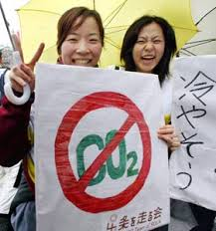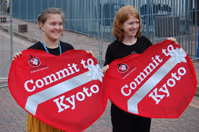 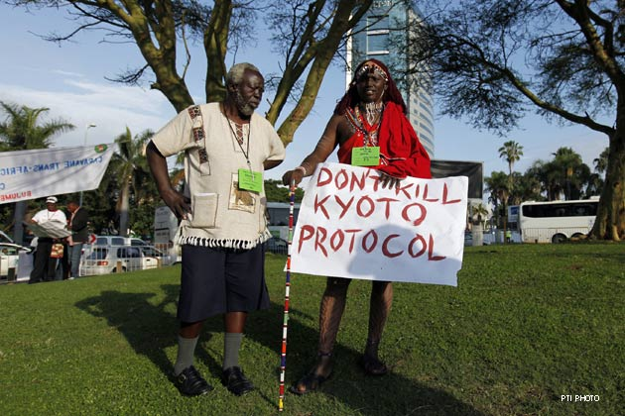

Time line:

**1992** The UN Conference on the Environment and Development is held in Rio de Janeiro. It results in the Framework Convention on Climate Change [("FCCC" or "UNFCCC")](http://www.unfccc.int/) among other agreements.

**1995** Parties to the UNFCCC meet in Berlin (the 1st Conference of Parties (COP) to the UNFCCC) to outline specific targets on emissions.

**1997** In December the parties conclude the Kyoto Protocol in Kyoto, Japan, in which they agree to the broad outlines of emissions targets.

**2002** Russia and Canada ratify the Kyoto Protocol to the UNFCCC bringing the treaty into effect on 16 February 2005.

**2011** Canada became the first signatory to announce its withdrawal from the Kyoto Protocol.

**2012** On 31 December 2012, the first commitment period under the Protocol expired.

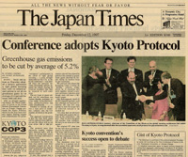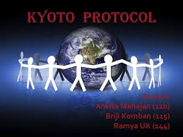

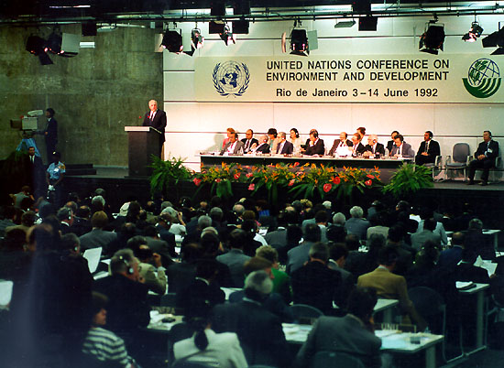**Points of Controversy:**

The Kyoto Protocol was created in 1997, but it has still not been put into effect. There has been a general reluctance to accept the agreement since controversy surrounds a number of issues. The UNFCCC has held annual conferences to discuss and address these issues and the individual concerns of some countries, but little progress has been made. This has lead some to state that the Kyoto Protocol is fundamentally flawed, but before passing this judgment, the points of controversy should be examined individually:

### Penalties for Non-Compliance / Withdraw

At present, no penalties exist for a country that ratifies the Protocol and fails to meet its reduction targets. Possibilities under consideration include financial penalties, trade sanctions, and emissions penalties under future climate change agreements. The details for such penalties have not been established and negotiations have been very slow and difficult.

Furthermore, any country can withdraw from the treaty after ratifying it by simply giving one year's notice. This part of the treaty, coupled with the lack of penalties for non-compliance, has come under harsh criticism from the scientific community: as it stands, the Kyoto Protocol is completely unbinding and seems to embody something that does not need to be taken seriously since there are no consequences for non-compliance.

### What constitutes an "emissions reduction”?

Although all countries that signed the Kyoto Protocol agreed to greenhouse gas "reductions," they did not agree on what exactly is to be counted as "reductions."

Some countries, particularly Canada and Russia with their large forests, argued that they should receive credits towards their reduction targets for these "carbon sinks" that absorb greenhouse gases out of the atmosphere from across the globe. Other countries argued that integrating the planting of forests as a part of regular industrial projects should count in the same sort of way.

Unfortunately, no real method exists for quantifying the actual benefits of either proposal, and while some allowances have been made, all of the parties involved claim that they have not yet been credited enough.

### The Kyoto Mechanisms

Under the Kyoto Protocol, there are three Mechanisms that allow countries and companies to buy, generate, or trade "emissions credits." These credits then count towards the country's reduction target.

The Mechanisms are known as International Emissions Trading - buying credits from other industrialized countries that have exceeded their reduction targets, Joint Implementation - investing in emissions reduction projects in other industrialized countries, and Clean Development - investing in clean energy and other emission reduction projects in developing countries. The logic behind all of the Mechanisms is that the planet as a whole does not care where the reductions in emissions are achieved, simply that they are achieved somewhere. As such, by investing in a reduction project on the other side of the globe, a country is still contributing to its own reduction quota.

The controversy concerning the Mechanisms surrounds the fact that the methods for their actual use have yet to be finalized. If implemented, a new global market would emerge surrounding energy credits, and they would be traded much in the same way as other commodities such as oil or coffee. Prices would fluctuate with supply and demand, and there would certainly be ample opportunities for profits and losses.

## No methods for regulating this market have been finalized, and some argue that it detracts the Kyoto Protocol away from its true goal. By creating a global marketplace out of emissions trading, the treaty would essentially transform the act of reducing emissions into a game of economics from its true meaning of achieving goals that will improve the quality of life on the planet.

## Shortcomings of the Protocol:

In addition to having controversial flaws that impede the implementation of the Protocol, there are a number of fundamental shortcomings with the ideas behind the treaty that question its benefit as a whole.

### Exclusion of Developing Countries

While many argue that it would not be viable to require developing nations to meet reduction targets under the Kyoto Protocol, their exclusion raises serious questions about the overall effectiveness of the agreement.

Many developing countries make use of older, dirtier technologies or simply lack the infrastructure and policies to develop environmentally-friendly alternatives. As such, by not including such countries, they will continue to rely on these older technologies as their economies and populations grow. Their emissions will continue to grow without being limited by the Kyoto Protocol, so any gains made by the nations under the Protocol could be easily offset by the growth of emissions in the developing world.

This shortcoming is best shown by the fact that China and India, which together represent one third of the world's population and are growing rapidly in terms of industrial capacity, are left completely unchecked in terms of greenhouse gas emissions.

If the Kyoto Protocol is to achieve its goal of reducing global emissions, it will have to be changed to include all countries of the world, each contributing accordingly.

### Costs and Economic Implications

A global reduction in greenhouse gas emissions provided by the Kyoto Protocol might be beneficial in the future, but a comparison of its immediate benefits to its costs is hardly favorable.

The costs of implementing the treaty, when considered in terms of direct costs, loss of jobs, and long-term economic implications, are of such a magnitude that many experts think there are far more important immediate global priorities to be considered. While no finite estimate of how much the Kyoto Protocol would cost has been prepared, projects such as providing clean water to the world's population, which would save millions of lives annually, could be realized for a fraction of the cost and have far more immediate benefits.

## Result: Too Little, Too Late:

The final, and perhaps most important, criticism of the Kyoto Protocol is that it simply represents too little, too late. When it initially presented its findings to the United Nations in 1990, the [Intergovernmental Panel on Climate Change (IPCC)](http://www.ipcc.ch/) charged that a drastic reduction of greenhouse gas emissions in the range of 60 to 80 percent was necessary just to slow the process of climate change to an acceptable rate that would allow ecosystems to adapt. Even if it were implemented at 100% effectiveness, the Kyoto Protocol barely represents any progress at all, both because its reduction targets are low and emissions in developing countries will continue to grow unchecked. The following charts represent forecasts made comparing various levels of emission reductions for the next century: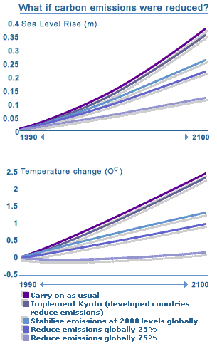

## Concluding Remarks:

While international agreements such as the Kyoto Protocol are certainly a step in the right direction in that they raise awareness about the severity of global climate change, they are not a complete solution and will not solve the problem alone. Real results and improvements will be seen when fundamental reductions in energy consumption and changes in lifestyle are achieved on an individual level across the globe.



# C:\Users\OM\Desktop\Optimized-coal.jpgCARBON SEQUESTRATION METHODS

**What is Carbon sequestration?**

**Carbon sequestration** is the process involved in carbon capture and the long-term storage of atmospheric *carbon dioxide (CO2)*. Carbon sequestration describes long-term storage of carbon dioxide or other forms of carbon to either mitigate or defer global warming and avoid dangerous climate change. It has been proposed as a way to slow the atmospheric and marine accumulation of greenhouse gases, which are released by *burning fossil fuels*.

Carbon dioxide is naturally captured from the atmosphere through biological, chemical, and physical processes. Artificial processes have been devised to produce similar effects, including large-scale, artificial capture and sequestration of industrially produced CO2 using *subsurface saline aquifers, reservoirs, ocean water, aging oil fields, or other carbon sinks*.

**Methods for sequestrating:**

Terrestrial sequestration:

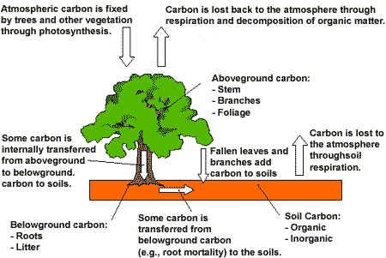

Terrestrial sequestration involves the capture and storage of carbon by plants and the storage of carbon in soil. During [**photosynthesis**](http://teeic.indianaffairs.gov/glossary/glossary.htm#422), carbon from atmospheric carbon dioxide is transformed into components necessary for plants to live and grow. As part of this process, the carbon present in the atmosphere as carbon dioxide becomes part of the plant: a leaf, stem, root, etc. Long-lived plants like trees might keep the carbon sequestered for a long period of time. Once the tree dies, or as limbs, leaves, seeds, or blossoms drop from the tree, the plant material decomposes and the carbon is released. The figure to the right depicts natural terrestrial sequestration. It has two types:

1. Soil Sequestration

Enhancing the storage of carbon in soil

1. Plant Sequestration

Enhancing the storage of carbon in forests and other vegetation

Geographical sequestration:

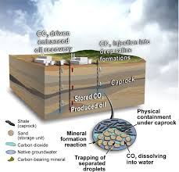

Geological sequestration stores carbon dioxide underground in the pore spaces of rock formations that already contain water, brine, oil, and/or natural gas. In fact, injecting CO2into coal seams and mature oil fields can help extract coaled methane and oil that would otherwise be left in the ground, helping to offset the cost of carbon sequestration.

Ocean Sequestration

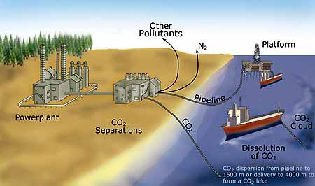

The ocean represents the largest carbon store on earth. If CO2 were to be injected to the ocean bottom; the pressures would be great enough for CO2 to be in its liquid phase. The idea behind ocean injection would be to have stable, stationary pools of CO2 at the ocean floor. The ocean could potentially hold over a thousand billion tons of CO2. However, this avenue of sequestration isn’t being as actively pursued because of concerns about the impact on ocean life, and concerns about its stability.

River mouths bring large quantities of nutrients and dead material from upriver into the ocean as part of the process that eventually produces fossil fuels. Transporting material such as crop waste out to sea and allowing it to sink exploits this idea to increase carbon storage. International regulations on marine dumping may restrict or prevent use of this technique.

Minerals Sequestration:

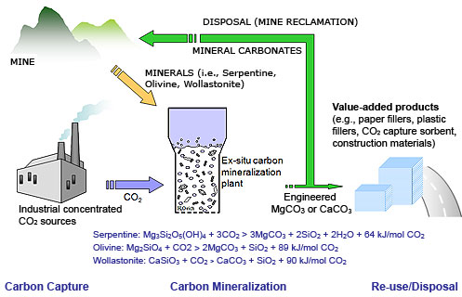

Mineral carbon dioxide sequestration refers to a technology whereby carbon dioxide is disposed of via the creation of magnesium or calcium carbonate solids, the thermodynamic ground state of carbon. Despite the potential for permanent storage and zero monitoring costs via this technology, research efforts to develop this technology are small relative to other sequestration technologies such as geologic storage. Despite current high costs estimates, increasing amounts of research both from geochemical studies and those directly devoted to developing cost-effective mineral sequestration pathways provide evidence that a low-cost process may be developed.

**Problems faced while handling carbon sequestration:**

### Danger of leaks

Carbon dioxide may be stored deep underground. At depth, hydrostatic pressure acts to keep it in a liquid state. Reservoir design faults, rock fissures and tectonic processes may act to release the gas stored into the ocean or atmosphere.

CO2 Levels at Leaking Canadian Carbon Storage Project

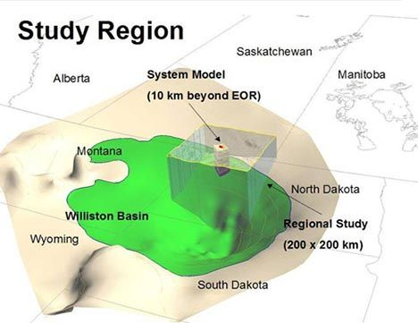

### Financial costs

Some argue that the cost of carbon sequestration would actually increase over time. The use of the technology would add an additional 1-5 cents of cost per kilowatt hour, according to estimate made by the Intergovernmental Panel on Climate Change. The financial costs of modern coal technology would nearly double if use of CCS technology were to be implemented.

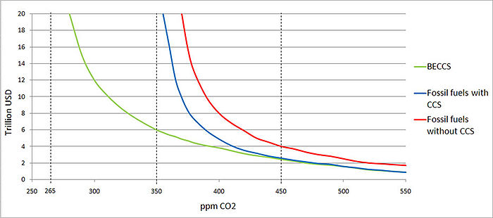

### Energy requirements

The energy requirements of sequestration processes may be significant. In one paper, sequestration consumed 25 percent of the plant's rated 600 megawatt output capacity.After adding CO2 capture and compression, the capacity of the coal-fired power plant is reduced to 457 MW.

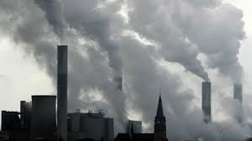

## MONTREAL PROTOCOL C:\Users\OM\Desktop\download (2).jpg

The **Montreal Protocol on Substances that Deplete the Ozone Layer** (a protocol to the [Vienna Convention for the Protection of the Ozone Layer](https://en.wikipedia.org/wiki/Vienna_Convention_for_the_Protection_of_the_Ozone_Layer)) is an international treaty designed to protect the ozone layer by phasing out the production of numerous substances that are responsible for ozone depletion. It was agreed on 26 August 1987, and entered into force on 26 August 1989, followed by a first meeting in Helsinki, May 1989. Since then, it has undergone eight revisions, in *1990 (London), 1991 (Nairobi), 1992 (Copenhagen), 1993 (Bangkok), 1995 (Vienna), 1997 (Montreal), 1998 (Australia), 1999 (Beijing) and 2007 (Montreal)*. As a result of the international agreement, the ozone hole in Antarctica is slowly recovering. Climate projections indicate that the ozone layer will return to 1980 levels between 2050 and 2070. Due to its widespread adoption and implementation it has been hailed as an example of exceptional international co-operation, with Kofi Annan quoted as saying that "perhaps the single most successful international agreement to date has been the Montreal Protocol”. In comparison, effective burden sharing and solution proposals mitigating regional conflicts of interest have been among the success factors for the Ozone depletion challenge, where global regulation based on the Kyoto Protocol has failed to do so. In case of the ozone depletion challenge, there was global regulation already being installed before a scientific consensus was established. As well in comparison, lay people and public opinion were more convinced about possible imminent risks.

The two ozone treaties have been ratified by 197 parties, which include 196 states and the European Union, making them the [first universally ratified treaties](https://en.wikipedia.org/wiki/List_of_treaties_by_number_of_parties) in United Nations history.

These truly universal treaties have also been remarkable in the expedience of the policy making process at the global scale, where bare 14 years lapsed between a basic scientific research discovery (1973) and the international agreement signed (1985 & 1987). When comparing this very success story with attempts to establish an international policy on the Earth's climate or atomic energy, the entire process from a problem formulation to a global acceptance supported by a legal framework took less than a quarter of a single human generation life span.

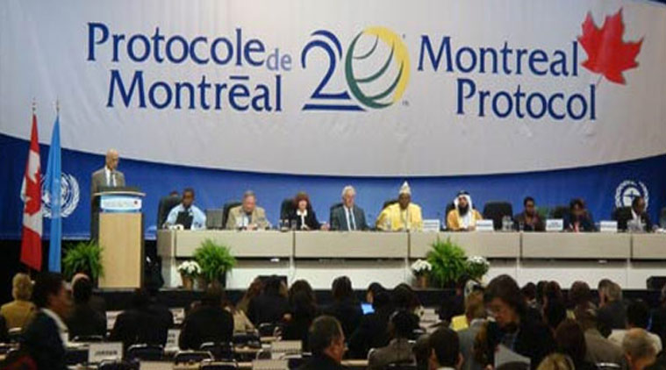

**Timeline:**

*Montreal Protocol (1987)*  
CFCs (11, 12, 113, 114, 115): Phase down 1986 levels by 20% by 1994; 50% by 1999.

*London Amendment (1990)*  
CFCs 13, 111, 112, 211, 212, 213, 214, 215, 216, 217: Phase down 1989 levels 20% by 1993; 85% by 1997; 100% by 2000.  
Halons (1211, 1301, 2402): Phase down 1986 levels 50% by 1995; 100% by 2000.  
Carbon Tetrachloride: Phase down 1989 levels 85% by 1995; 100% by 2000.

*Copenhagen Amendment (1992)*  
CFCs: phase out by 1995  
Halons: phase out by 1993  
Carbon Tetrachloride: phase out by 1995  
HCFCs: phase down 1989 levels 35% by 2004; 90% by 2019; 100% by 2029.

The Montreal Protocol has been further adjusted in Vienna (1995), Montreal (1997) and most recently in Beijing (1999). The Beijing Amendment (1999) has introduced a freezing of HCFC production by 2003.

**Effects:**

Since the Montreal Protocol came into effect, the atmospheric concentrations of the most important chlorofluorocarbons and related chlorinated hydrocarbons have either leveled off or decreased. Halon concentrations have continued to increase, as the halons presently stored in fire extinguishers are released, but their rate of increase has slowed and their abundances are expected to begin to decline by about 2020. Also, the concentration of the HCFCs increased drastically at least partly because for many uses (e.g. used as solvents or refrigerating agents) CFCs were substituted with HCFCs. While there have been reports of attempts by individuals to circumvent the ban, e.g. by smuggling CFCs from undeveloped to developed nations, the overall level of compliance has been high. Statistical analysis from 2010 shows a clear positive signal from the Montreal Protocol to the stratospheric ozone.In consequence, the Montreal Protocol has often been called the most successful international environmental agreement to date. In a 2001 report, NASA found the ozone thinning over Antarctica had remained the same thickness for the previous three years; however in 2003 the ozone hole grew to its second largest size. The most recent (2006) scientific evaluation of the effects of the Montreal Protocol states, "The Montreal Protocol is working: There is clear evidence of a decrease in the atmospheric burden of ozone-depleting substances and some early signs of stratospheric ozone recovery."

[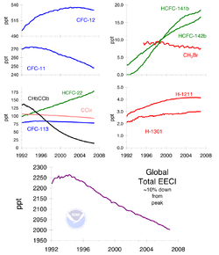](https://en.wikipedia.org/wiki/File:Ozone_cfc_trends.png)

The Montreal Protocol is also expected to have effects on human health. A 2015 report by the U. S. Environmental Protection Agency estimates that the protection of the ozone layer under the treaty will prevent over 280 million cases of skin cancer, 1.5 million skin cancer deaths, and 45 million cataracts in the United States.

However, the hydro chlorofluorocarbons, or HCFCs, and hydro fluorocarbons, or HFCs, are now thought to contribute to [anthropogenic global warming](https://en.wikipedia.org/wiki/Anthropogenic_global_warming). On a molecule-for-molecule basis, these compounds are up to 10,000 times more potent greenhouse gases than carbon dioxide. The Montreal Protocol currently calls for a complete phase-out of HCFCs by 2030, but does not place any restriction on HFCs. Since the CFCs themselves are equally powerful greenhouse gases, the mere substitution of HFCs for CFCs does not significantly increase the rate of anthropogenic global warming, but over time a steady increase in their use could increase the danger that human activity will change the climate.

Policy experts have advocated for increased efforts to link ozone protection efforts to climate protection efforts. Policy decisions in one arena affect the costs and effectiveness of environmental improvements in the other.

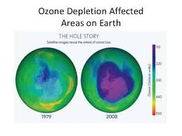



**Conclusion:**

The Montreal Protocol is a remarkable instrument. It broke new ground in its negotiation and in its construction. It is ratified or accepted by all 197 UN member states, a world first for any treaty and highlighting the strong global commitment to this treaty.

Most importantly it is doing its job well. The ozone layer is expected to return to 1980 levels between 2045 and 2060 as long as all countries continue to meet their obligations and phase out the last ozone-depleting substances in the next few years.

Phasing out ozone-depleting substances has also benefited the environment more broadly, as many ozone-depleting substances also have high global warming potential. It is a credit to governments, industry, environment groups, science and technical experts that such an instrument is even in existence and doing such a great job.

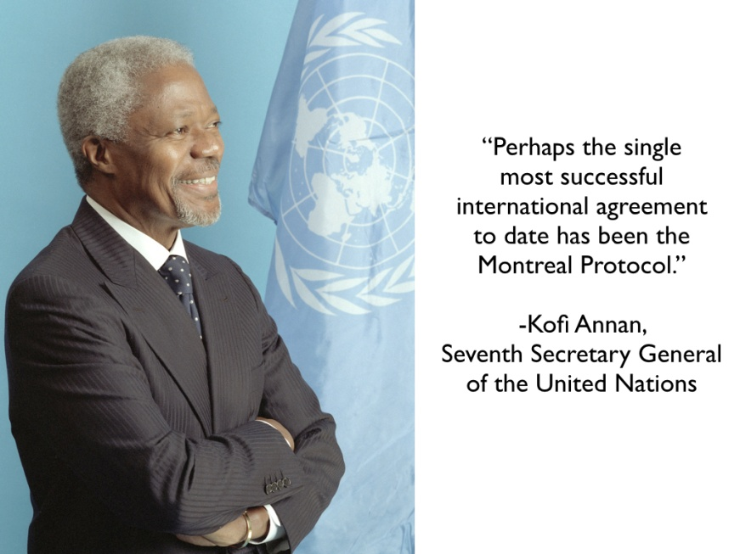

**BIBLIOGRAPHY:**

* <http://climatechange.sea.ca/kyoto_protocol.html>
* [https://en.wikipedia.org/wiki/**Kyoto**_**Protoco**l](https://en.wikipedia.org/wiki/Kyoto_Protocol)
* [**https://en.wikipedia.org/wiki/Carbon_sequestration**](https://en.wikipedia.org/wiki/Carbon_sequestration)
* [**http://www.esrl.noaa.gov/gmd/icdc7/proceedings/abstracts/krevorMC95Oral.pdf**](http://www.esrl.noaa.gov/gmd/icdc7/proceedings/abstracts/krevorMC95Oral.pdf)
* [**http://www.treehugger.com/clean-technology/co2-levels-at-leaking-canadian-carbon-storage-project-could-asphyxiate-you-in-one-place.html**](http://www.treehugger.com/clean-technology/co2-levels-at-leaking-canadian-carbon-storage-project-could-asphyxiate-you-in-one-place.html)
* [www.theozonehole.com/**montreal**.htm](http://www.theozonehole.com/montreal.htm)
* Sir’s PPT
* Google images



Thank You

